**Xerox Star**

Xerox 8010 Star (1981年推出)

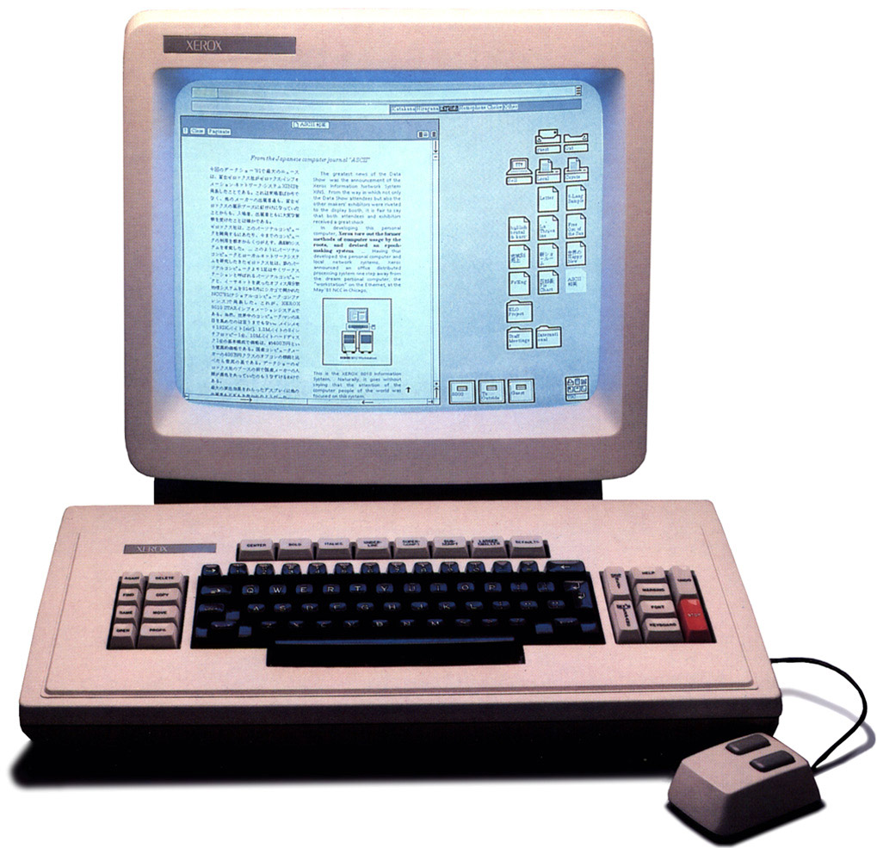

这是第一台全集成桌面电脑，包含应用程序和图形用户界面（GUI），一开始叫 *The Xerox Star，*后改名为 *ViewPoint，* 最后又改名为 *GlobalView。*

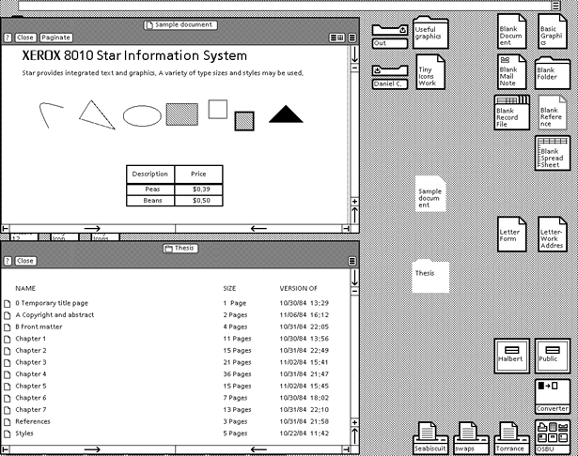

*Xerox 8010 Star, Source:* [*toastytech.com*](http://toastytech.com/guis/starbitmap2.gif)

**Xerox Star图标（1981年）**  
  
　　1981年的Xerox Star系统用的是只有72象素×72象素的黑白图标。当时的显示器只有72点每英寸（PPI）的分辨率，每一个图标刚好是一平方英寸。（见图1）

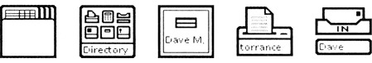

　　Xerox Star系统中的图标十分抽象，只用了圆形和矩形。当时制定的一些图标到今天都还在被使用，比如说，一个折了一角的空白纸张表示一个文档，一个淡黄色的文件夹表示一个目录，放了一张纸的桶表示一个垃圾回收站。

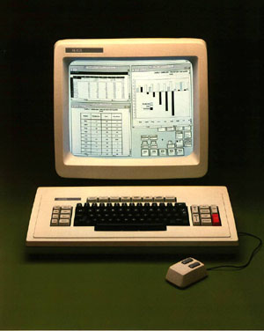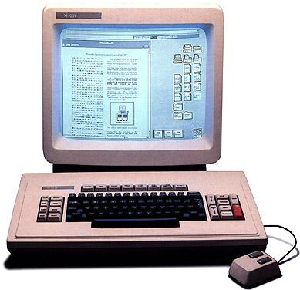

　　令人惊讶的是，Xerox Star系统中所有图标有很好的一致性，在图标的细节上也表现的很好。比如说，当收件箱或发件箱有信件未处理时，收件箱或发件箱的图标的外层就会多了一层；时钟的图标就像我们日常可以见到的时钟；图标的名称也是图标本身的一部分。

目录

• [简介](http://www.techcn.com.cn/index.php?doc-view-140634.html#1)

• [详解](http://www.techcn.com.cn/index.php?doc-view-140634.html#3)

• [相关网站](http://www.techcn.com.cn/index.php?doc-view-140634.html#5)

• [参考文献](http://www.techcn.com.cn/index.php?doc-view-140634.html#7)

简介[回目录](http://www.techcn.com.cn/index.php?doc-view-140634.html" \l "section)

The Star workstation, officially known as the Xerox 8010 Information System, was introduced by Xerox Corporation in 1981. It was the first commercial system to incorporate various technologies that today have become commonplace in personal computers, including a bitmapped display, a window-based graphical user interface, icons, folders, mouse, Ethernet networking, file servers, print servers and e-mail.

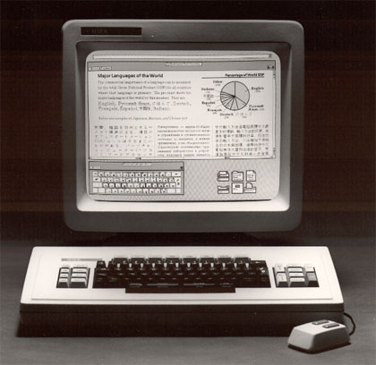

The name "Star" technically refers only to the software sold with the system for the office automation market. The 8010 workstations were also sold with LISP- and Smalltalk-based software, for the smaller research and software development market.

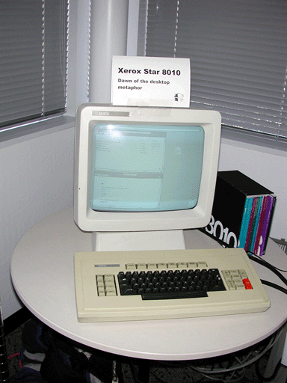

详解[回目录](http://www.techcn.com.cn/index.php?doc-view-140634.html" \l "section)

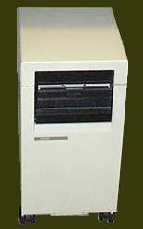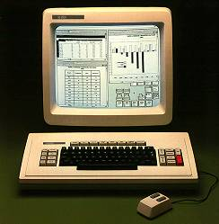  
The Xerox 8010 Information System

The 8010 Information System from Xerox was the first system to use a fully integrated desktop metaphor and application suite. Initially the term "Star" referred to the desktop and application software. However the system as a whole became commonly known as "The Xerox Star." The software was later renamed to "ViewPoint", and later renamed again to "GlobalView."

Development of the Star started in 1977 and used concepts from the Alto. Development started on early development machines, codenamed Dolphin and Dorado, that could also run the Alto software. The final result was completely new software written in Xerox's MESA programming environment rather than BCPL, which the Alto software was written in. (BCPL even used different microcode) The final 8010/Dandelion hardware was not backwards compatible with the Alto.

First commercially sold in 1981, the Original Xerox 8010, Codename Dandelion, specs were:

* Custom processor based on the AMD 2900 bit-sliced microcode programmable microprocessor
* 384 KB (expandable to 1.5MB) of real memory
* 10, 29 or 40 MB hard drive
* 8-inch floppy drive
* 17-inch display
* Display resolution of 1024*808 monochrome
* 2-button Mouse
* Ethernet networking
* "Pilot" operating system
* "Star" desktop software

Print servers for these systems were manufactured using the same base hardware and also ran Pilot OS. Print servers used a TTY terminal instead of a graphics display and did not include the video graphics hardware or Star desktop software. Xerox 1108 AI Workstations were also manufactured using the same base hardware but were packaged with Interlisp-D instead of the Star software.

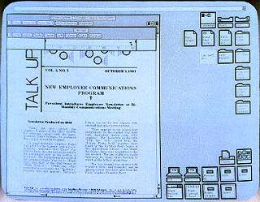

The design of the Star focused around four important principles:

* Seeing and pointing
* Progressive disclosure
* Uniformity in all applications
* "What you see is what you get"

The display of the Star mimics a desk environment. Files, storage locations, and other functionality are represented as icons. At the time, graphical "icons" were a relatively new concept and term in the computer field.

A few other interesting things to note: The border of the video image is covered by the monitor's shell, the idea being to make the desktop look less like a picture. Also, the original Star desktop does not have the "Waste Basket". This is added much later.

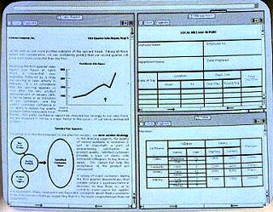  
In the original Star software, application windows are tiled in such a way that do **not** overlap. Property windows and other dialogs, however may overlap. The idea is to make optimal use of limited screen space. Also, when the first window is opened it will usually open so as not to cover the icons on the right.

Of the application software included with the Star, the most important and visible is the document editor. The document editor supports complex layouts with columns, tables, diagrams, and embedded images.

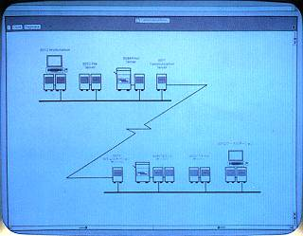  
Networking is a huge component of the Xerox Star. It includes ethernet networking hardware to communicate with other computers.

The Star has the ability to connect to file servers, mail servers, and print servers. It also includes software to emulate TTY terminals and 3270 terminals over the network.

Someone even managed to run a web server off of one of these once!

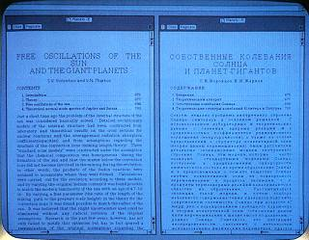  
All of the Star applications support multiple languages. Instead of using ASCII text, they are implemented using an early version of Unicode. Fonts for many different languages are included.

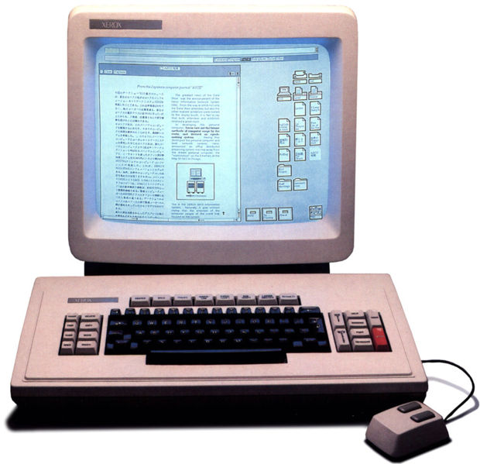

相关网站[回目录](http://www.techcn.com.cn/index.php?doc-view-140634.html" \l "section)

• [The first GUIs - Chapter 2. History: A Brief History of User Interfaces](http://www.catb.org/~esr/writings/taouu/html/ch02s05.html)

• [Star graphics: An object-oriented implementation](http://portal.acm.org/citation.cfm?id=801270)

• [Traits: An approach to multiple-inheritance subclassing](http://portal.acm.org/citation.cfm?id=966873.806468)

• [The design of Star's records processing: data processing for the noncomputer professional](http://portal.acm.org/citation.cfm?id=357425)

• [The Xerox "Star": A Retrospective.](http://members.dcn.org/dwnelson/XeroxStarRetrospective.html)

• [The Xerox "Star": A Retrospective.](http://www.guidebookgallery.org/articles/thexeroxstararetrospective) (with full-size screenshots)

• [Dave Curbow's Xerox Star Historical Documents (at the Digibarn)](http://www.digibarn.com/friends/curbow/star/index.html)

• [The Digibarn's pages on the Xerox Star 8010 Information System](http://www.digibarn.com/collections/systems/xerox-8010/index.html)

• [Xerox Star 1981](http://www.thocp.net/hardware/xerox_star.htm)

• [HCI Review of the Xerox Star](http://xeroxstar.tripod.com/)

• [GUI of Xerox Star](http://toastytech.com/guis/star.html)

参考文献[回目录](http://www.techcn.com.cn/index.php?doc-view-140634.html" \l "section)

http://en.wikipedia.org/wiki/Xerox_Star  
http://www.digibarn.com/friends/curbow/star/retrospect/